Tip
You can press the following keyboard shortcut combination to access Settings on Visual Studio Code:
CTRL + , (on Windows and Linux)
CMD + , (on Mac)
In Settings, you can apply different customizations that fit your personal IDE style. For example, you can change the font settings of the text editor:
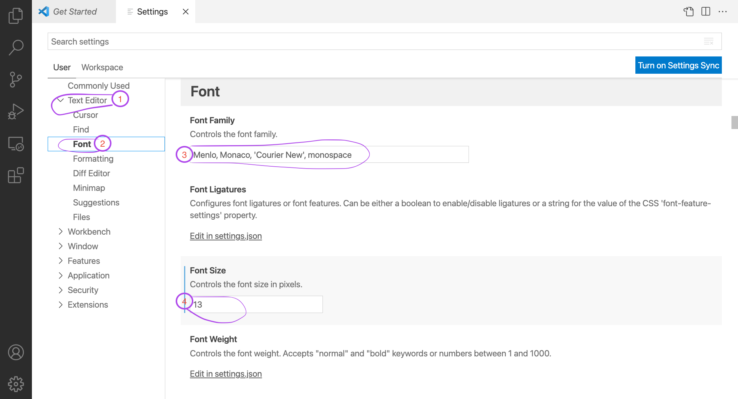

You can also search for a specific setting in the search box:
